**Learning Outcomes**

1. Simple ListView Control
2. Understanding ListActivity and ArrayAdapter
3. Understanding CardView

**ListActivity**

Android includes built-in ListActivity that you can use without defining any custom layout XML or code. The ListActivity class automatically creates a ListView and exposes a ListAdapter property to supply the row views to display via an adapter.

**SimpleListItem1**

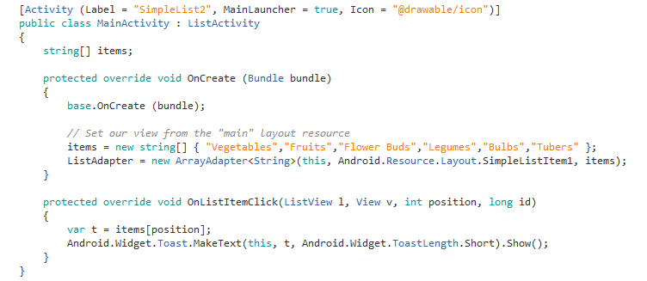

**Points to Note**

Inheriting your main activity as a ListActivity

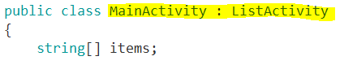

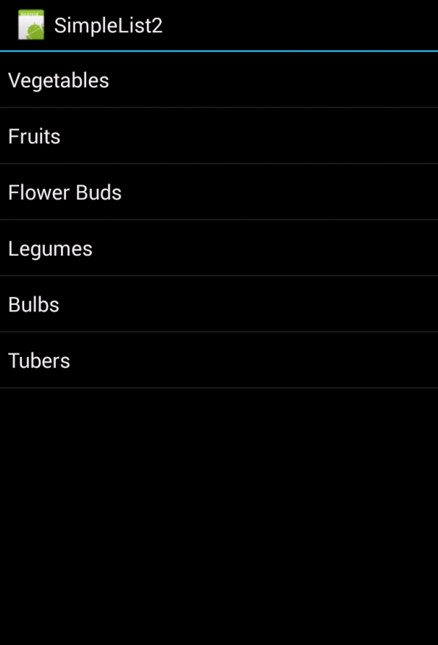

**Variations**



**For a Single Selected Item**

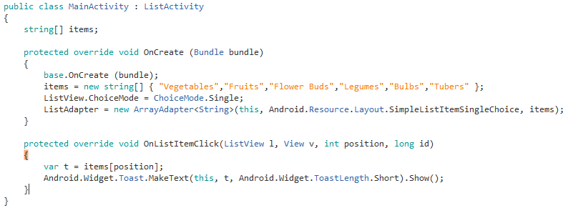

Note the difference



**For Multiple Selection**

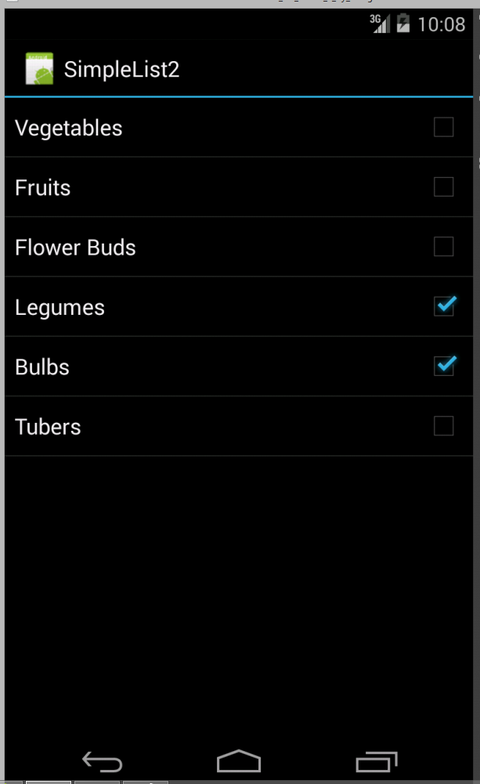

**Modify the code as follows**

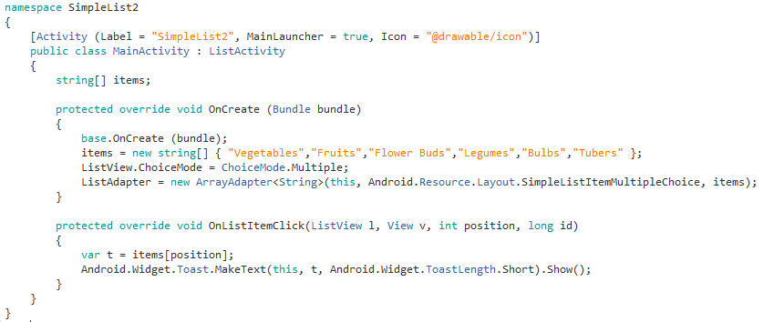

**Implement Simple GroceryList App**

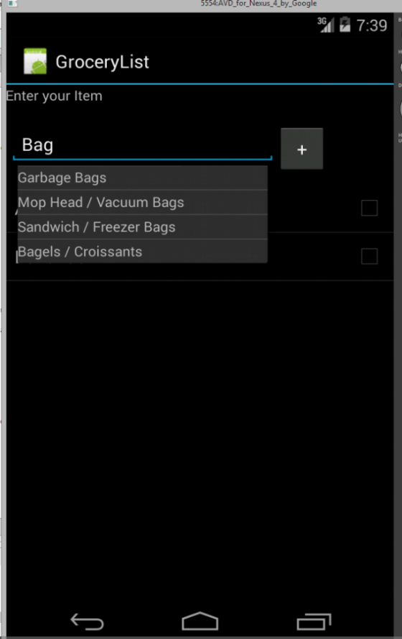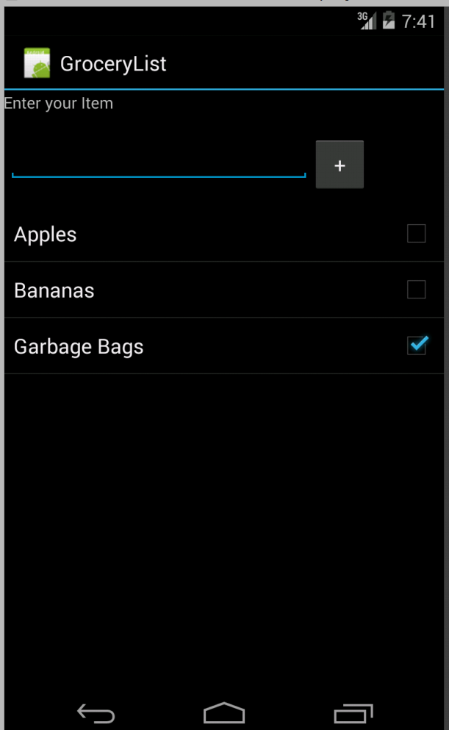

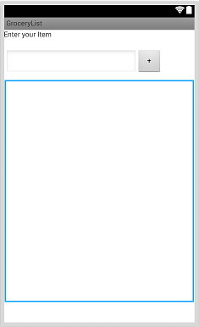

Label, Autocomplete TextView, Button and a Listview

Add your grocery Items in Strings.xml

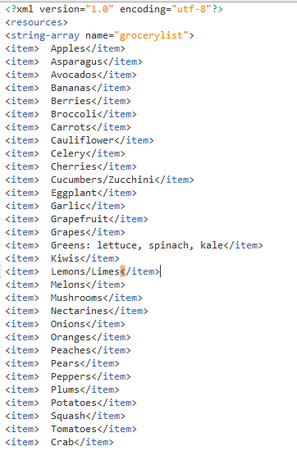

**Code**

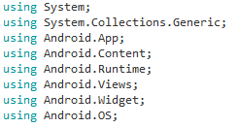

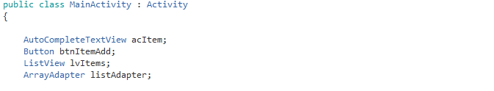

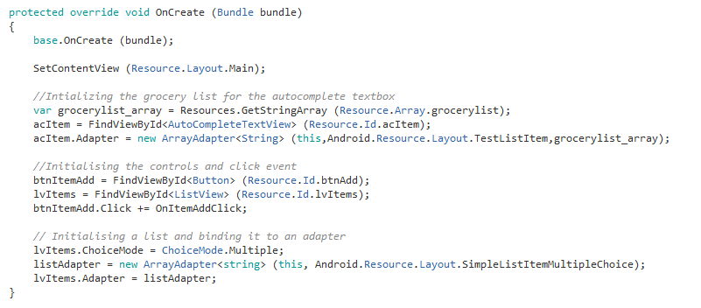

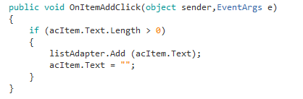

**Introducing Android CardView**

Android 5.0 (Lollipop) includes the new CardView widget. This **guide** explains how to use and customize CardView in Xamarin.Android applications while maintaining backward compatibility with versions of Android before Lollipop.

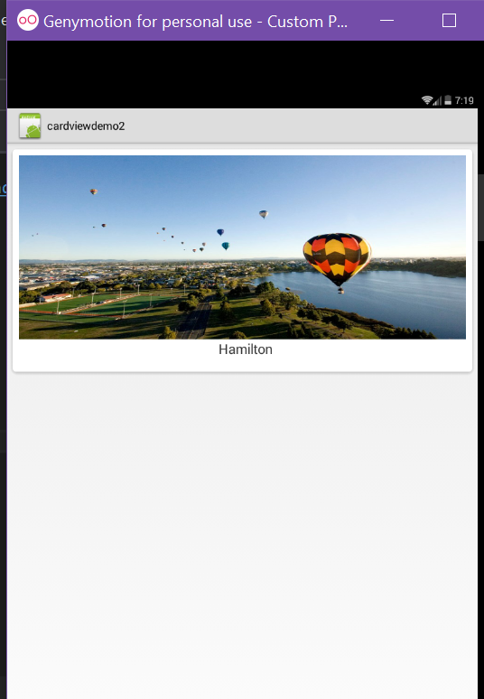

You need to add the Xamarin.Android.Support.v7.CardView package in Visual Studio:

1. Open your project, right-click the References node (in the Solution Explorer pane) and select Manage NuGet Packages....
2. When the Manage NuGet Packages dialog is displayed, enter CardView in the search box.
3. When Xamarin Support Library v7 CardView appears, click Install.

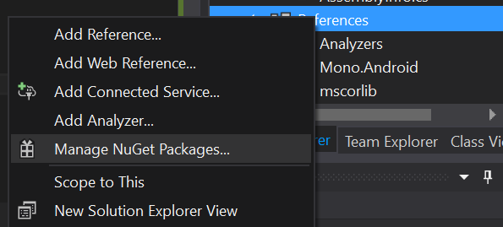

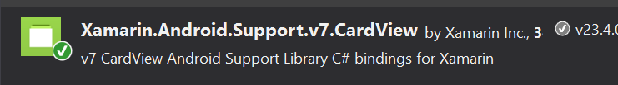

Now in your AndroidManifest.xml add the theme attribute

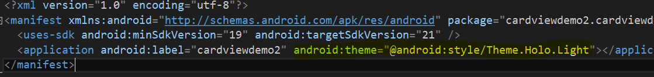

**Change your projects target/minimum and compile version in project properties**

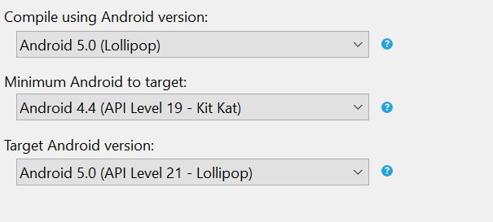

**Main.axml**

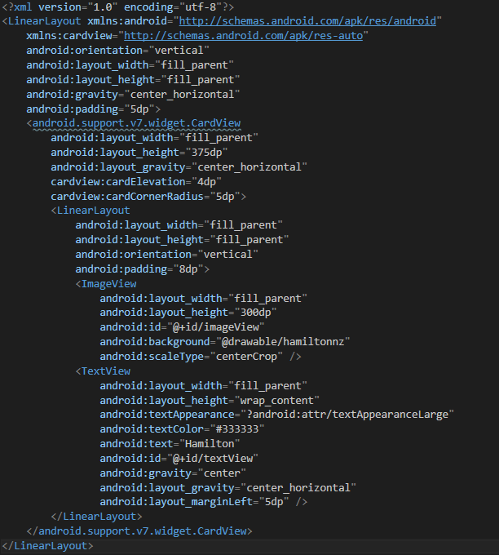

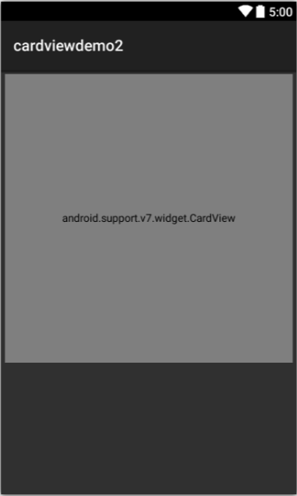

You can copy the layout code from [**https://developer.xamarin.com/guides/android/user_interface/cardview/**](https://developer.xamarin.com/guides/android/user_interface/cardview/)

**Add a picture to your drawable folder**

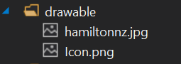

Comment out your default code or delete it

**Exercise**

**Send Text Message to Contacts (Bulk Texting)**

In this app the user can send a text to multiple users. The app allows you to select a number of users and send them a text.

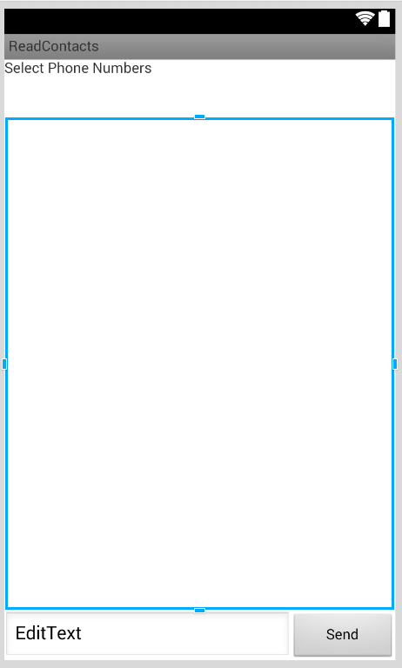

Permissions required are SendSMS and Read Contacts. The permissions are set in the AndroidManifest.xml file.

In Visual Studio you can do it via Project Properties.

Go to Project -> (Project Name) Properties

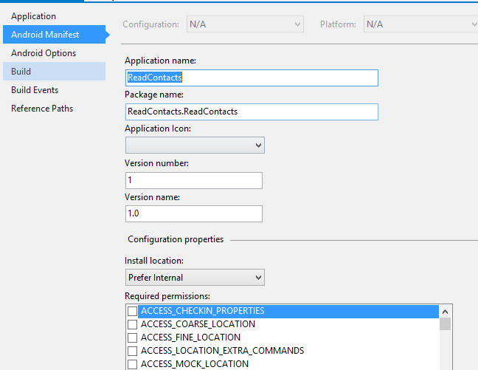





To read contacts

<https://developer.xamarin.com/recipes/android/data/contentproviders/read_contacts/>

To display phone number

<https://forums.xamarin.com/discussion/18813/reading-contact-name-and-number>

**OR**

Using Xamrin.Mobile component

<http://components.xamarin.com/view/xamarin.mobile>

You need to add the Xamarin.Mobile component to be able to read contacts of your phone.

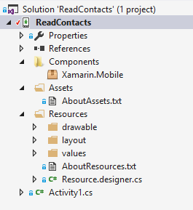

Add the appropriate using directives

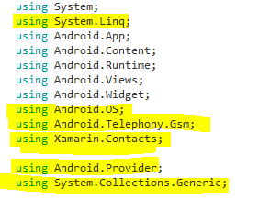

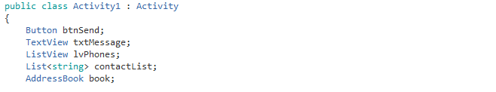

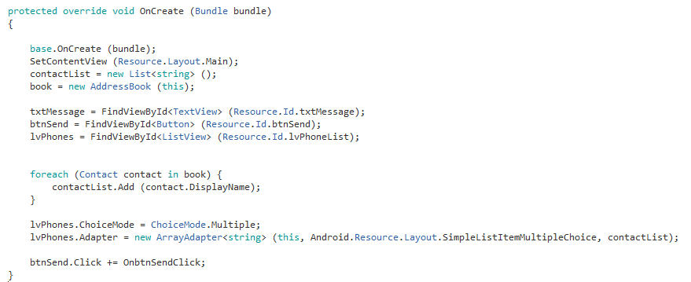

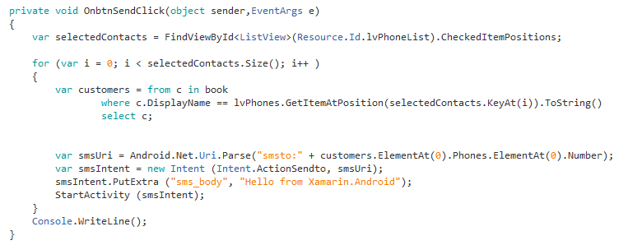

**Exercise**

The above approach needs you to press the send button to send the text.

Find a way to automatically send text messages.